

**PROJECT REPORT**

**Rhythmic Tunes: Your Melodic Companion**

YEAR : **2024 – 2025**

COLLEGE NAME : **K.C.S KASI NADAR COLLEGE OF ARTS & SCIENCE**

CODE : UNM203

DEPARTMENT : **COMPUTER SCIENCE**

PROGRAM : **B.Sc Computer Science**

SEMESTER : **VI**

PROJECT SUBMITTED TO: UNIVERSITY OF MADRAS / NAAN MUDALVAN

Course Name : **Front End Development and Database Administration**

**TEAM LEADER: HARISH KUMAR K EMAIL:** harikumaran2004@gmail.com

**MEMBERS: EMAIL**

1. GOKULRAM S GOKULRAM.S2004@gmail.com

2. VISVANATH S VISHVISHVA020@gmail.com

3. NAVEEN KUMAR B NAVEENBASKAR001@gmail.com

**GUIDED BY: Dr. S.KALAISELVI**

**SPOC NAME: Dr.K. LALITHAKAMESWARI**

Rhythmic Tunes: Your melodic companion

**(Music streaming application)**

# Introduction:

Welcome to the future of musical indulgence – an unparalleled audio experience awaits you with our cutting-edge Music Streaming Application, meticulously crafted using the power of React.js. Seamlessly blending innovation with user-centric design, our application is set to redefine how you interact with and immerse yourself in the world of music.

Designed for the modern music enthusiast, our React-based Music Streaming Application offers a harmonious fusion of robust functionality and an intuitive user interface. From discovering the latest chart-toppers to rediscovering timeless classics,our platform ensures an all-encompassing musical journey tailored to your unique taste.

The heart of our Music Streaming Application lies in React, a dynamic and feature-rich JavaScript library. Immerse yourself in a visually stunning and interactive interface, where every click, scroll, and playlist creation feels like a musical revelation. Whether you're on a desktop, tablet, or smartphone, our responsive design ensures a consistent and enjoyable experience across all devices.

Say goodbye to the limitations of traditional music listening and welcome a world of possibilities with our React-based Music Streaming Application. Join us on this journey as we transform the way you connect with and savor the universal language of music.Get ready to elevate your auditory experience – it's time to press play on a new era of music streaming.

# Fractures of Rhythmic Tunes :

* **Song Listings: Display a comprehensive list of available songs with details such as title, artist, genre, and release date.**
* **Playlist Creation: Empower users to create personalized playlists, adding and organizing songs based on their preferences.**
* **Playback Control: Implement seamless playback control features, allowing users to play, pause, skip, and adjust volume during music playback.**
* **Offline Listening: Allow users to download songs for offline listening, enhancing the app's accessibility and convenience.**
* **Search Functionality: Implement a robust search feature for users to easily find specific songs, artists, or albums within the app.**

# Project structure:

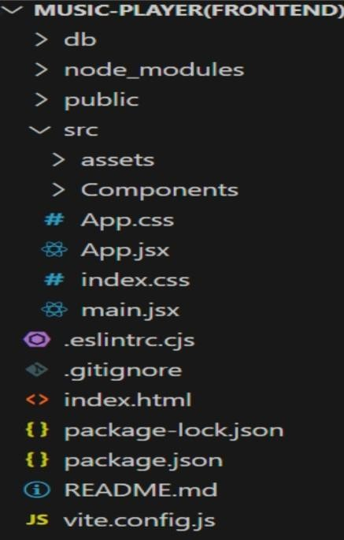,

# Project Execution:

Here are some of the screenshots of the application.

* + **Hero components**

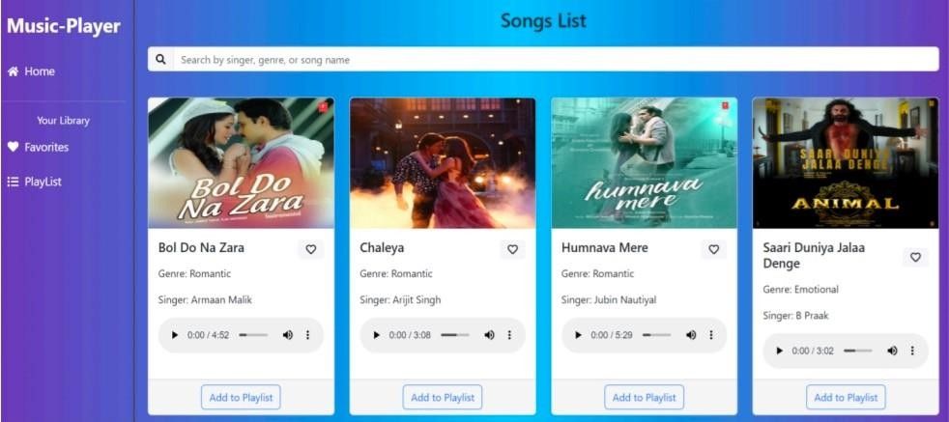

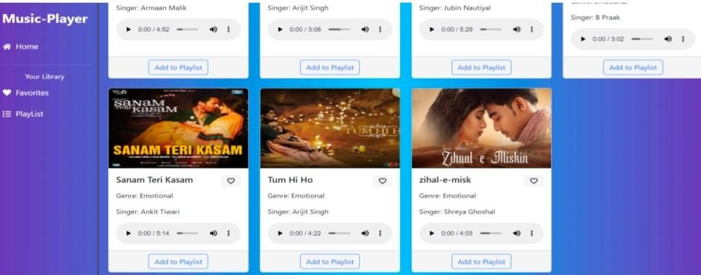

* + **Playlist**

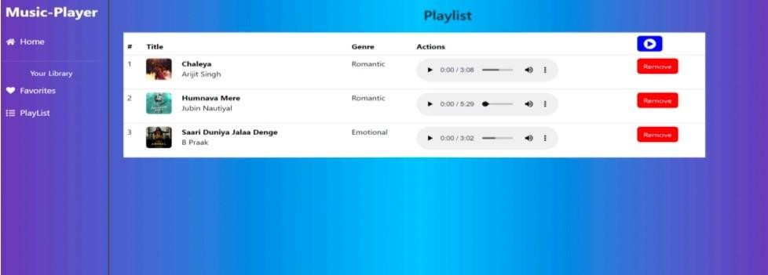

* + **Favourites**

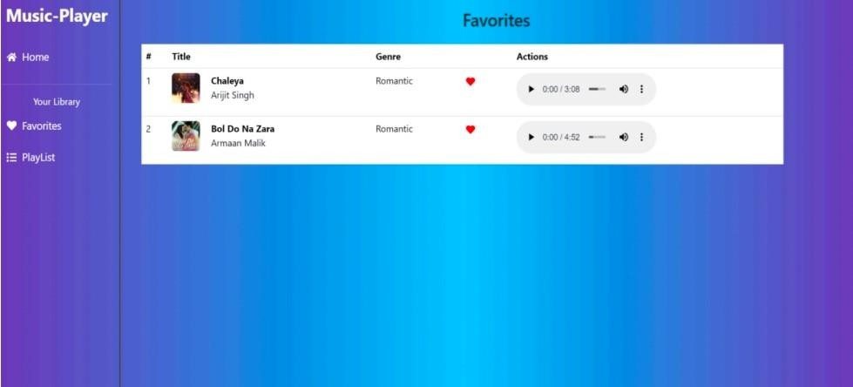

Project Demo link:

<https://drive.google.com/file/d/1obzA_eHmSoaNOIB-> oHNFCDJ08MVNhzxi/view?usp=drivesdk